Interfacing with UART of 8051 controller
This post provides the solution for using the 8051 controller UART interface (e-g to connect 8051 controller with PC using serial adapter). Complete code and simulation can be downloaded from the 'Downloads' section at the bottom of this post. The following figure shows the result of simulation of 8051 UART in Proteus7.7.
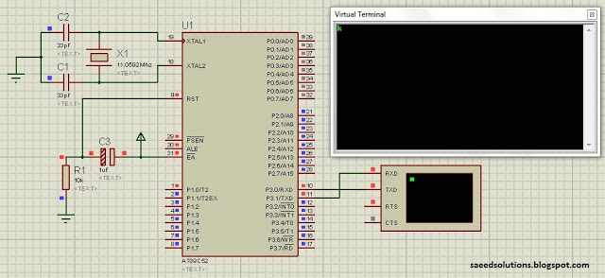
Figure 1. UART simulation for 8051 controller
In the figure above at89c52 controller is being used. You can use at89c51 controller as well in this schematic. 11.0592MHz crystal is used with the controller to generate baud rate of 9600 bps. The code for the main function is shown below.
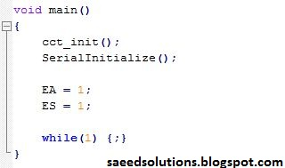
Figure 2. Main code for UART code of 8051
In the main function, circuit initialization function is called which sets the proper values at each port of 8051 controller. After that, UART is initialized using the 'SerialInitialize()' function. Details of these two functions can be found in the complete code which can be downloaded from the Downloads section below. [ Using SendByteSerially('H') statement, you can send 'H' character to Vitual Terminal or using serial adapter you can display this 'H' on Hyper Terminal on PC. This SendByteSerially() function is also defined in the code. ] Global interrupts are enabled using the command ' EA = 1 ' and then Serial port interrupts are enabled using the command ' ES =1 '. Rest of the time controller just executes the nop statements (i-e does nothing) until something is received on the UART, then controller executes the following code.
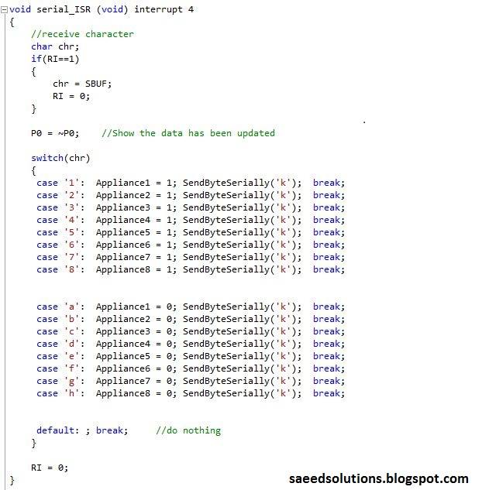
Figure 3. Interrupt code for UART of 8051
So, when ever a byte is received on the UART Receive path, then that character is saved in the variable 'chr' as shown above in the code. Then according to the 'chr' value different 'Appliances' are turned on or off. These 'Appliances' are just the name of some pins as shown below.
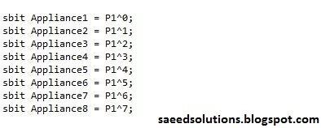
Figure 4. Port 1 pins name for 8051
After that an acknowledgment is sent in the form of character 'k' from the controller to the PC.
You can use MAX232 IC to connect this 8051 controller UART interface with your PC using serial adapter. Then using Hyper Terminal software, you can send or receive any character from PIC controller through your serial adapter cable.
This code is just an example on how the serial port of 8051 controller can be used. This code is basically part of a project named 'Internet to Serial control'. Details of this project can be found on another post. You can leave your comments in the comment section below.

